Understanding Leadership

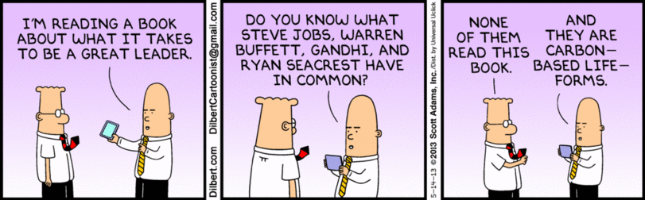
(joyreactor.com, n.d.)

Contents
Purpose 3
Learning Outcomes 3
What is Leadership? 4
Leadership Essentials 5
Activity: What does successful leadership look like? 5
Leadership Characteristics 6
Activity: Do you think how we define leadership has changed or needs to change? 6
Managers vs leaders 6
Leadership Theories 8
Abraham Maslow: Hierarchy of Needs 8
Activity: List needs that you have in each segment of the pyramid. 9
FISH 10
Frederick Herzberg: Two Factor Theory 11
John Adair: Actioned Centered Leadership 11
Activity: What actions do you need to take, as a leader, to execute the task, build the team and develop the individual? 12
John McGregor: Theory X and Theory Y 13
Activity: Think about the people on your team with regards to this 2-factory theory. 13
Bruce Tuckman: forming–storming–norming–performing 13
Activity: What happens when someone new joins the team? 15
Leadership Styles 15
Autocratic Leadership (Authoritarian) 16
Activity: Think of an autocratic leader who you have known. 16
Democratic Leadership (Participative) 17
Activity: Think of a democratic leader who you have known. 17
Laissez-faire Leadership (Hands-off) / Delegative 17
Activity: Think of a Laissez-faire leader who you have known. 18
Transformational Leadership (visionary leadership) 18
Activity: Identify and analyse a leader in the context of a particular leadership style 19
Situational Leadership Theory 20
Factors That Influence Which Leadership Style to Use 20
SWOT analysis 20
Personal Development Plan 22
SMART Goals 22
Activity: Your Leadership Aspirations 23
Activity: What you need to achieve your leadership aspirations 23
More Leadership Content 24

Purpose
To develop and understand leadership as required by a practising or potential first-time line manager.
To develop YOU, as a leader!

Learning Outcomes
Learning Outcomes: | Learner Can:
Understand leadership styles | Describe factors that influence the choice of leadership styles or behaviours in workplace situations
Understand leadership styles | Explain why leadership styles or behaviours are to have a positive or negative effect on individual and group behaviour
Understand leadership qualities and review own leadership qualities and potential | Assess own leadership behaviours and potential in the context of a particular leadership model and own organisation’s working  practices and culture, using feedback from others
Understand leadership qualities and review own leadership qualities and potential | Describe appropriate actions to enhance own leadership behaviour in the context of the particular leadership model

Leadership
Put simply, leadership is influencing others to act, and even think, in alignment with prescribed goals or vision.
Strong leadership causes forward movement in an organisation or system by changing the behaviours of others. It’s responsible for global systems working, education, food production, health care, government change and much more.
Leadership can inspire, infuriate, direct, enable, and prevent. Because of its significance in organisations and broader society, it’s valuable to understand how YOU are a leader and to be able to analyse those leading around you.

What is Leadership?
You are a leader.
If you are a parent, you are a leader. If you are a supportive friend in a difficult time, you are a leader. If you are managing a team of people driving towards a collective goal, you are a leader. A leader is not defined by status, letters after your name, or degrees. It is defined by the people who feel the impact of your behaviour and your actions.
Leaders can be positive, or they can be negative.
They can initiate tremendously good outcomes (think Gandhi) or they can cause real horror (think Hitler). Leaders can make people feel great and inspire them to help others (think of a community leader gathering people for a charitable purpose at a village hall). Leaders can bring out the worst in others and make people feel sad or threatened (think of a bully in a school classroom).
Leadership is simple.
Leaders set an example for others. Leaders care about the needs of the people they are leading. Leadership can be as simple as showing up and being present with your mind, thoughts, words and actions.
Leadership is complex.
Leadership is complex but being self-aware can help you be better able to lead others. Leaders are faced with constant and varied demands. They must often make rapid and challenging decisions. There always seems to be more demands than hours in the day. Some expectations of leaders are:
- Be a role model; commit to self-development
- Initiating actions which achieve organisational goals and outcomes
- Focus and – as required – refocus yourself and your team on the prescribed vision
- Exemplify and encourage collaboration
- Be positive
- Develop sophisticated listening skills and solicit feedback

Leadership Essentials
It’s all about the people.
Leadership is about people. It is the art (and science) of really understanding people and using this awareness to influence them.
Understand what motivates.
Leadership is informed by truly understanding what motivates the people who work for/ with you. Understanding human (general and specific) motivators precedes effective leadership.
Development of emotional intelligence.
Leadership demands emotional intelligence in the leader. The Oxford dictionary defines this as,” the capacity to be aware of, control, and express one's emotions, and to handle interpersonal relationships judiciously and empathetically.”
Use effective communication.
Learning to communicate effectively, understanding the various mediums of communication and how/when to use them as well as how to understand communication from others is critical to effective leadership.

Activity: What does successful leadership look like?
Think of leaders you have worked with and consider behaviours, skills and approaches they used to influence others around them. Describe behaviours, skills, and approaches which you consider to be a) successful and b) unsuccessful.
Behaviours, skills and approaches of successful leader(ship);

1………………………………………………………………………………………………………………………………

………………………………………………………………………………………………………………………………..

2.……………………………………………………………………………………………………………………………

………………………………………………………………………………………………………………………………..

3.…………………………………………………………………………………………………………………………

………………………………………………………………………………………………………………………………..

Behaviours, skills and approaches of UNsuccessful leader(ship);

1.……………………………………………………………………………………………………………………………

………………………………………………………………………………………………………………………………..

2. ……………………………………………………………………………………………………………………………

………………………………………………………………………………………………………………………………..

Leadership Characteristics
What do people think of when they think about leadership characteristics?

Honesty
Enthusiasm
Respect
Sensitivity
Recognition
Role modelling
Charisma
Authority
Foresight
The ability to change
High standards
Clear thinking
Sense of value
Sense of purpose
Decisiveness
Direction
Consistency

As our understanding of effective and empathetic leadership develops, we may see some of these characteristics as antiquated or out of date. Change is ever present and thus our understanding of effective leadership must change to meet the demands of the present situation.

Activity: Do you think how we define leadership has changed or needs to change?

Are there any qualities noted above which you think are unnecessary in today’s leaders? Or are there qualities which are missing from this list? Discuss.

………………………………………………………………………………………………………………………………

………………………………………………………………………………………………………………………………..

.……………………………………………………………………………………………………………………………

………………………………………………………………………………………………………………………………..

.………………………………………………………………………………………………………………………………

………………………………………………………………………………………………………………………………..

Managers vs leaders
Henri Fayol’s management functions state that managers:
- Plan
- Organize
- Command
- Coordinate
- Control
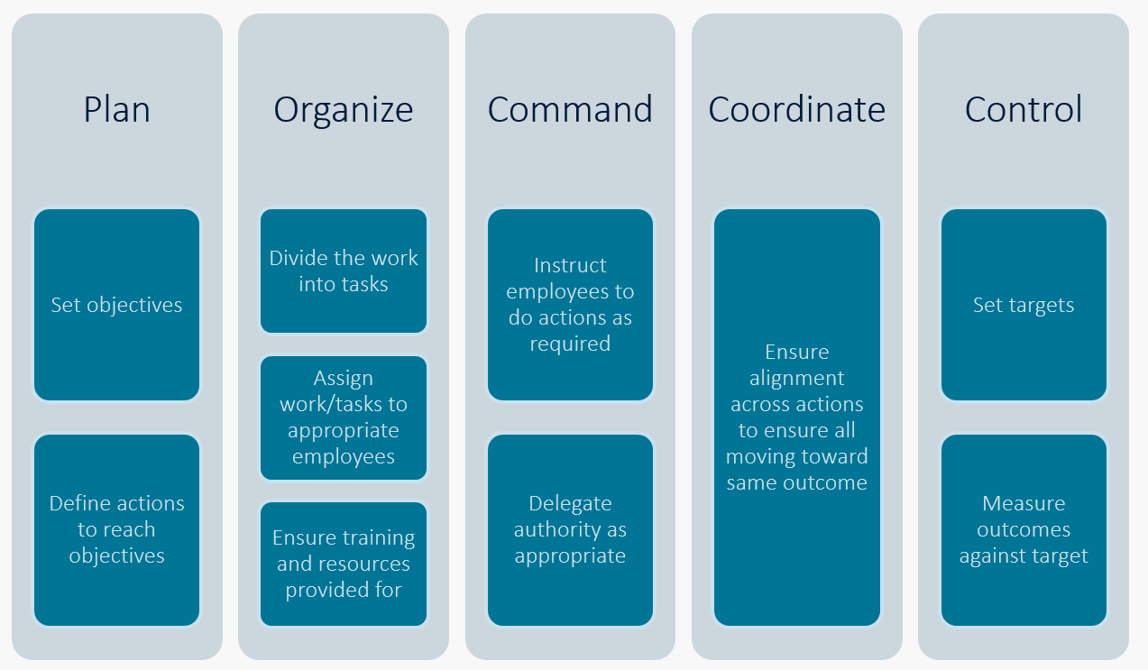
In contrast with what Fayol stated managers must do, leaders take each action one step further…
- Planning empowerment
- Organizing creating change
- Commanding taking people with you
- Coordinating changing beliefs
- Controlling creating enthusiasm
Managers provide the more concrete, logical and task-oriented direction. Leaders strategize and inspire towards the organisation’s vision.
- Managers administer, leaders innovate
- Managers ask how and when, leaders ask what and why
- Managers focus on systems, leaders focus on people
- Managers do things right, leaders do the right things
- Managers maintain, leaders develop
- Managers rely on control, leaders inspire trust
- Managers have a short-term perspective, leaders have a longer-term perspective
This does not for a moment suggest that managers offer a lesser provision to an organisation. In fact, in many cases, particularly in smaller organisations, managers are also leaders. One person must be nimble and able to see when a scenario or team requires managerial supervision or inspirational leadership. The lines are blurry between the two roles, but it is valuable to understand what the difference between the defined roles is and when to utilize the characteristics of one over the other.

Leadership Theories

There seem to be as many theories on leadership as there are people in the world who have studied leadership. Theories are simply that. Theories. Despite that they can seem arbitrary or unrelated to our daily work, theories provide useful frameworks from which to learn, compare and assess our own leadership styles and our own team dynamics. As you review some theories offered below, consider how you might apply the model to your own style or team.

“What is necessary to change a person is to change his awareness of himself.” Abraham Maslow
***

Abraham Maslow: Hierarchy of Needs
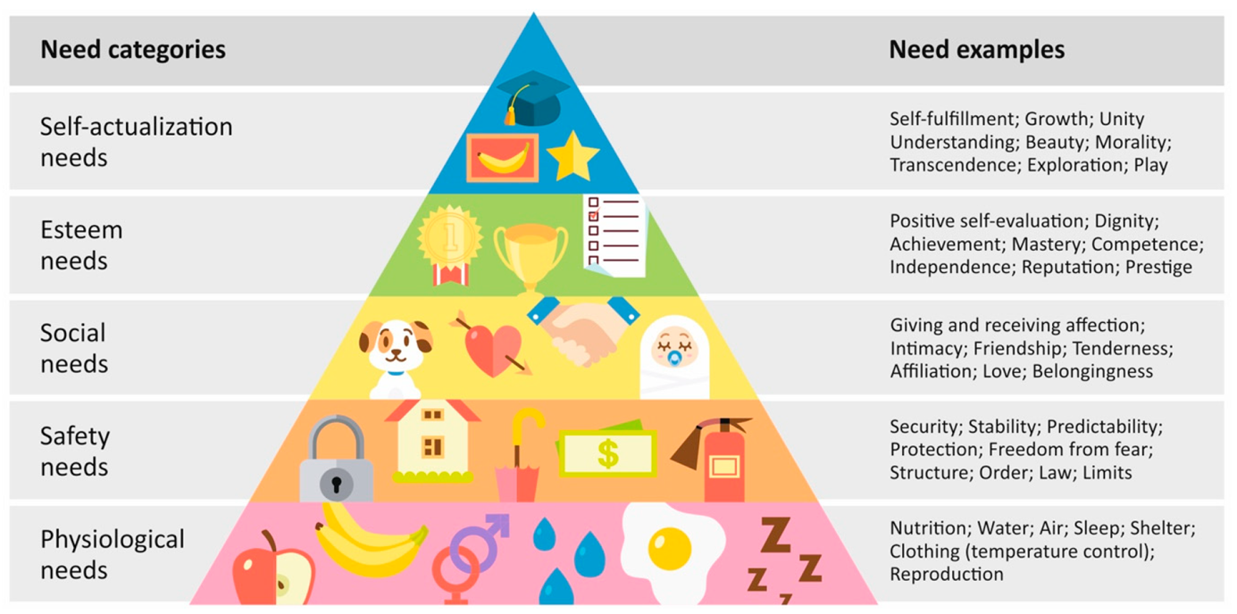
https://www.mdpi.com/2414-4088/4/3/38/htm
Perhaps one of the best-known theories on human motivation is that produced by psychologist Abraham Maslow. His “hierarchy of needs” states that an individual will not be motivated to move towards a higher level of attainment without first having the more fundamental needs met.
Physiological needs
These needs are fundamental to human existence and include oxygen, food, water, clothes, sleep and other biological needs. Although this goes without saying in most scenarios, its valuable to note here that sleep is mentioned, and many comprehensive studies of the western world suggest the average adult gets less than the recommended 8 hours sleep. Thus, its important to understand that unmet physiological needs will negatively impact individual wellbeing and thus performance at work.

Safety needs
Safety needs can be easily grouped with physiological needs as they are also tremendously impactful on one’s sense of wellbeing. Such needs include a sense of personal security, health and wellbeing, protection from accidents and illnesses, and the absence of fear.
Social needs
Social needs are the feeling of societal acceptance and belonging. Social needs relate to relationships and interactions with others, familial relationships and intimacy and having a sense of community.
Esteem needs
Described as external and internal, esteem needs set the stage for “self-actualization” needs. These needs pertain to the intellectual and emotional condition and growth of an individual.
Internally motivating esteem needs | Externally motivating esteem needs
- Self-esteem  - Accomplishment and achievement  - Self-respect  - The urge to be strong and competent  - Self confidence  - Independence and autonomy | - Reputation and recognition by others  - Need for status  - Recognition and fame  - Prestige  - Positive affirmation and attention

Self-actualization needs
“What a man can be, he must be.” (Maslow, 1954)
Essentially this is the need of the individual to become everything that he/she is capable of becoming. Self-actualization needs lead to realising one’s full potential.
***
“Nobody can put you in a bad mood without your permission.” Pete Cicero
In thinking about each level of self-development, list some of the things you feel you need to be successful and continue developing. Consider, as you do this, that each member of your team may have different needs to develop and feel safe.

Activity: List needs that you have in each segment of the pyramid.
Physiological Needs

Safety Needs

Social Needs

Self Esteem needs

Self-actualization Needs

Are there needs that are essential for you that are missing from your work/life? What can you do to change this?

Now think about an example where an employee might not have had their needs met or they may have been struggling with needs from one of the categories because of a challenging life issue. Discuss how this impacted their ability to be fully present and successful at work.

FISH
“Suddenly a fishmonger [in Seattle’s Pike Place Market] fired a slippery salmon to a coworker, who made a spectacular one-handed catch as the crowd applauded. He invited a delighted customer to catch a fish.”
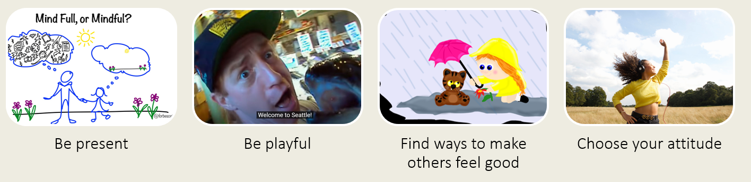
Another theory of leadership comes from the filmmaker John Christensen. On a walk, through Pike Place Market in Seattle, he witnessed a fishmonger displaying outstanding leadership and a clearly happy, cohesive team. This led to his own research and development of the FISH model. The model is simple and perhaps more difficult to apply than it seems.
- Be present – Being present with your employees and team allows for genuine listening, dialogue and awareness of the situation and oneself. Mental presence takes practice and diligence especially in today’s electronic world.
- Be playful – the power of play has been repeatedly demonstrated and though its affects and those of laughter can have excellent results to organisational cultural, its important to define parameters so playfulness is enabled appropriately for the nature of the work.
- Find ways to make others feel good – A kind word, genuine thanks, simple and authentic compliment can create warmth and intimacy which sets the stage for positive interactions within a team.
- Choose your own attitude – We cannot control all of the parameters of our jobs and teams, but we can choose our attitude. Once again, a habit which becomes easier with practice, positivity is contagious and improves team culture.

It’s the job of a manager not to light the fire of motivation, but to create an environment to let each person’s personal spark of motivation blaze.
Frederick Herzberg

Frederick Herzberg: Two Factor Theory
Psychologist, Frederick Herzberg developed a “2 factor model of motivation” in which he proposed that two sets of workplace characteristics work independently to each other; one set led to employee satisfaction and the other set led to employee dissatisfaction. Notably, he claimed that the two sets of characteristics did not influence the other and are experienced by the employee as separate motivators.
Factors contributing to satisfied employees | Factors contributing to dissatisfied employees
“Higher-level psychological needs”  Achievement  Advancement  Nature of the work  Recognition  Responsibility | Monetary compensation  Working conditions  Work relationships  Supervisory treatment  Company policies

“The factors that led to satisfaction (achievement, intrinsic interest in the work, responsibility, and advancement) are mostly unipolar; that is, they contribute very little to job dissatisfaction. Conversely, the dis-satisfiers (company policy and administrative practices, supervision, interpersonal relationships, working conditions, and salary) contribute very little to job satisfaction.”
— Herzberg, 1964
Consider what this might mean for your team and their motivators/ demotivators.
Effective leadership is not about making speeches or being liked; leadership is defined by results, not attributes. — Peter Drucker

John Adair: Actioned Centered Leadership
British Author, John Adair developed the action centered leadership model in contrast to the notion that leadership is defined by a set of characteristics in a leader. Instead, he suggested that leadership is really about focused actions more than a leadership style. The essential actions are to:
- Execute the task
- Develop and build the team
- Nurture and grow the individuals

Activity: What actions do you need to take, as a leader, to execute the task, build the team and develop the individual?
List the actions below in each column
Task | Team | Individual

TASK
- Define team's tasks, priorities, and purpose
- Help to create or delegate the making of SMART goals (Specific, Measurable, Achievable, Relevant, and Time-Bound)
- Allocate resources
- Ensure accountability
- Define and agree quality standards
- Monitor/ review performance
- Assess and report back on progress of task

TEAM
- Agree and set working standards
- Take a skills and competencies inventory and provide training for gaps
- Facilitate conflict resolution
- Enable and exemplify collaborative communication
- Work to build team cohesion
- Provide feedback on overall performance to the team
- Identify the team's culture, and its working style
- Alter group composition

INDIVIDUAL
- Define individual roles
- Encourage individual development plans
- Allot time to listen to and understand everyone’s needs, fears, motivations, aspirations, challenges
- Offer support as needed
- Provide thoughtful, constructive feedback
- Provide an avenue for introverted individuals to add input

John McGregor: Theory X and Theory Y
This American social psychologist believed that leaders fall into 2 categories, those who believe employees generally want to work and those who believe they generally don’t. McGregor worked in conjunction with Maslow; the common thread in their theories is that leadership style efficacy is related to what the leader believes about their employees’ motivations and needs towards work.
Theory X leaders are authoritative. They believe employees need to be directed, indeed prefer it, will avoid work if they can and require the threat of consequences to be coerced into working. McGregor believed that Theory X leaders get poorer results than Theory Y leaders, who lead with a more enlightened perspective.
Theory Y leaders are participative. They assume employees are capable of self-direction and motivation and when allowed, will problem solve, be creative and independently work towards the aims of the organisation.
Leaders who lean more towards X or Y theory will implement strategies for leading in line with what they expect their employees to need: direction, boundaries, consequences (theory X) and resources, opportunities for development and independence (theory Y). It’s of course likely that most leaders use some combination of these mindsets depending on the organisation, the employees, and the demands of the situation.

Activity: Think about the people on your team with regards to this 2-factory theory.
Consider those who benefit from a more authoritative (X) or participative (Y) leadership. Why might one leadership approach work in one instance but not in another?

Bruce Tuckman: forming–storming–norming–performing
American professor, Bruce Tuckman developed these stages of team evolution to describe what he felt each team must go through to problem solve and produce results as a group.

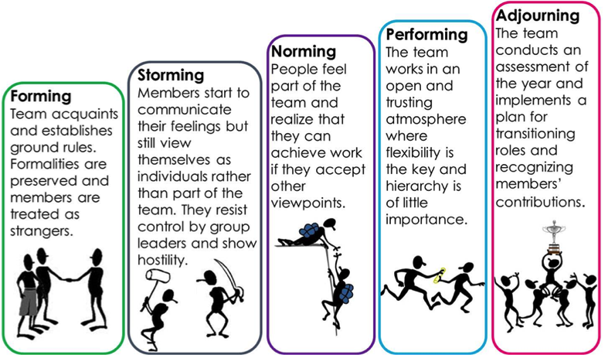
http://elearning.youthline.co.nz/mod/book/tool/print/index.php?id=621
- Forming: Everyone is on their best behaviour; team begins to set habits and ground rules for team interactions and systems. To move to the next phase, team members need to be honest about needs and expectations and accept the possibility of conflict.
- Storming: People begin to express their opinions and disagreements may arise. This phase can be upsetting but also productive. This phase moves forward when team members begin to speak openly and work towards resolution.
- Norming: Personality differences are accepted and the team begins to work together. The team sees the common goal and moves together toward it. It’s important to encourage more introverted team members and channel enthusiasm of extroverts to establish balance.
- Performing: Team works with improved understanding of each other and an has established acceptance of differences.
- Adjourning (mourning): an updated version of this model includes a closure point celebrates achievements or takes time to reflect and learn from the past.
Things to consider:
- Team members moving in and out of the group may cause the team to step back into a previous phase though established teams with the value of development and openness may allow new team members to come in with minimal upset to the team’s overall development.
- Changes in leadership may create challenges for the team and again require revisiting of the stages.

Leadership is not about titles, positions or flowcharts. It is about one life influencing another. ― John Maxwell

Activity: What happens when someone new joins the team?
Think about what stage of this theory the team is in and how the joining team member might impact that (or be influenced by the team). What can you do to facilitate smooth transitioning into the team?

Leadership Styles
German American psychologist Kurt Lewin is considered the first to study basic leadership styles. A leader may utilize combinations of styles depending on the scenario, the leader’s preference, and the nature of the team.
There are pros and cons to each style which may depend on the type of organisation (a hands-off approach probably won’t work in a military environment) or a situation the organisation may be faced with (a democratic leadership style might not be best suited for an urgent turnaround scenario).
As you review each type, think about how you might use characteristics of one or another style and in what scenario or with what types of team members.

“A leadership style is the behaviour pattern that a leader adopts to provide direction, set goals, implement plans and motivate people.” - Iulia-Cristina Uta (Uta, 2020)

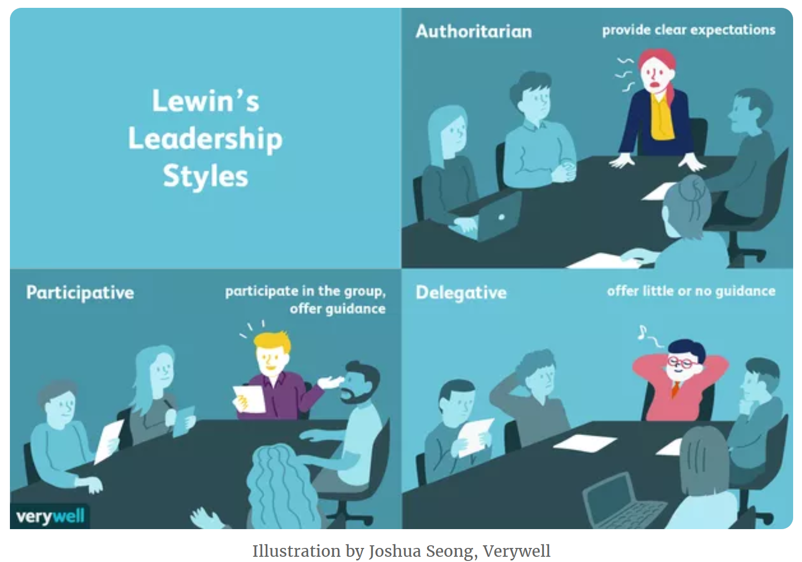

Autocratic Leadership (Authoritarian)
- Nutshell: Do what you’re told.
- The autocratic leader dictates strategy, policy, procedure and are not concerned with collaboration.
- Rarely solicit or consider feedback and prefer to be in charge and maintain power
- Leader is not openly hostile but offers “personal” praise as well as criticism to employees
- Leader qualities are usually decisiveness, self-confidence, and a steadfast, focused commitment to the goal
Pros:
- Functions in urgent or chaotic situations which require effective and fast decision making
Cons
- Employee may not feel valued and may feel micromanaged
- Can be leader dependent such that when leader is not present, there is lacking direction

Activity: Think of an autocratic leader who you have known.
Think about how it felt to be led by this type of leadership. Consider if it worked or didn’t. Elaborate.

Democratic Leadership (Participative)
- Leader gathers input from employees
- Everyone given chance to contribute to the decision-making process
- Leaders encourage creativity and improved outcomes are seen from increased collaboration
- Leader is objective in feedback and works to be seen as part of the team
- Leader is curious which drives desire for soliciting input from all team members
- Leader is an excellent communicator and seen as approachable
Pros
- Creates buy-in from the whole team because employees feel heard and valued
Cons
- More talkative employees may conceal the voice of more introverted employees and thus some may feel left out.
- May take longer as more time and meetings and collaboration required for democratic process

Activity: Think of a democratic leader who you have known.
Think about how it felt to be led by this type of leadership. Consider if it worked or didn’t. Elaborate.

Laissez-faire Leadership (Hands-off) / Delegative
- Characterized by empowerment of employees and maintaining a hands-off approach
- Leaders allow employees to make decisions
- Leaders are available to provide feedback as required
- Leader provides materials and will provide information or input if asked; otherwise nonparticipative
- Excellent delegators; trusting of their employees
- Translated means “let it be” or “allow to do”
Pros
- Provides for fast decision making as employee doesn’t need approval
- Well designed for experienced and trained employees
- Leads to employees feeling bought in and empowered
Cons
- Can lead to rapid failure if team is not capable or motivated to get the job done
- If team doesn’t understand the mission, they make not work in a cohesive manner

Activity: Think of a Laissez-faire leader who you have known.
Think about how it felt to be led by this type of leadership. Consider if it worked or didn’t. Elaborate.

Leadership expert James MacGregor Burns coined the term transformational leadership in the 1970s and it is offered here as an additional approach to Kurt Lewin’s commonly accepted 3 main styles of leadership.

Transformational Leadership (visionary leadership)
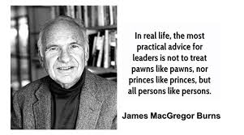
https://leadershipcoaching.com.au/wp-content/uploads/2018/02/James-MacGregor-Burns-1.jpg
- Leader develops the vision and enrolls employees
- Employees experience their own transformation and improvement if this leadership style is working
- The goal is clearly communicated and the team rallies behind the leader in achieving the goal
- Leader has ability to enroll others, is an expert communicator and has a strong sense of loyalty and commitment to bigger picture
- Leader understands what needs to change
Pros
- Employees are enrolled and feel loyal, thus are productive
- The workplace feels harmonious and enjoy collaborative communication
Cons
- Can lead to employee burnout if expectation of goal achievement is unrealistic
- This style requires constant and thorough communication; if this fails, the efficacy of this leader can decrease (UAGC, n.d.)

Activity: Identify and analyse a leader in the context of a particular leadership style
Describe a leadership scenario in which you were involved or witnessed and identify which style(s) the leader used. Was it effective? Could the leader have applied concepts from an additional style(s) to be more effective?
Describe scenario

Identify which style(s) you feel were used and discuss its efficacy.

Could the leader have applied ideas from an additional style and been more effective? Discuss.

Situational Leadership Theory
This theory suggests that leaders choose a leadership style based on the situation they have before them; this adaptability increases the likelihood of successful leadership.
Key: It’s important to evaluate every scenario and team before determining the right course of action, style of communication and level of delegation or direction required.

Factors That Influence Which Leadership Style to Use
The situational leadership theory states that leaders may use a particular style of leadership depending on certain factors.
Leaders may also use characteristics from more than one style. Factors that may influence the choice of leadership style include:
- The leader’s preference or predisposition
- His/her employees
- The organisation
- The scenario at hand
- External factors
The Leader
Abilities, beliefs, natural aptitudes, vision for the company, predispositions, aspirations, previous work and educational experiences and training
The employees
Ability and experiences managing various situations, ability to self-manage and initiate decision making, level of confidence in role, understanding of responsibilities and job functions
The Organisation
Prescribed vision, values, unstated rules and culture, industry regulations and standards, written procedures and policies
The Situation
Urgency or predictability of the specific situation, the parameters for failure or measure of upset if completed outside of expected norms, level of ambiguity about the procedure, time sensitivity to decide or complete
The External Factors
Depending on the specific scenario this could include demands of customers, materials procurement factors, stakeholder requirements, government or regulatory challenges or changes, societal/economic/political conditions.

SWOT analysis
A good place to evaluate your own leadership is to carry out a SWOT analysis, to candidly think about your Strengths, Weaknesses, Opportunities and Threats to your leadership style. Be as honest as you can with yourself, think of feedback you’ve had from others and think holistically.

STRENGTHS  What are your strengths?  What are your natural aptitudes and abilities?  In what circumstances do you thrive? | WEAKNESSES  With respect for work, what is difficult for you?  What scenarios challenge or stress you?  What leaves you feeling depleted?
OPPORTUNITIES  What are your longer term leadership/personal goals?  How can your strengths be leveraged to reach these goals?  Are there ways you are underutilizing your strengths/ holding yourself back? | THREATS  What stands in the way of you achieving your leadership goals?  Why do you think these factors contribute to preventing you improving?  What can you do to improve upon these challenges? What self-development, training or reflective practice could you apply to turn these scenarios into positive outcomes for you and the team?

Your SWOT Analysis

STRENGTHS | WEAKNESSES
OPPORTUNITIES | THREATS

Using the SWOT analysis, list 4 actions you could take to be improve your leadership development. These might include implementing concepts learned herein, training or further upskilling you could undertake or soliciting feedback from colleagues.

1.……………………………………………………………………………………………………………………..

………………………………………………………………………………………………………………………..

2.……………………………………………………………………………………………………………………..

………………………………………………………………………………………………………………………..

3.……………………………………………………………………………………………………………………..

………………………………………………………………………………………………………………………..

4.……………………………………………………………………………………………………………………..

………………………………………………………………………………………………………………………..

Personal Development Plan

Leaders aspiring to improve their leadership are on a constant path of self-development. Despite that it takes time and effort to improve, the outcomes in enhanced leadership abilities pay back dividends in improved team results, a happier group working environment and a sense of self achievement for the leader. A professional development plan (PDP) is a valuable tool to help practice self-awareness and challenge yourself to integrate new skills. A PDP is:
- Individual to you
- Regularly reviewed and updated
- Discussed with your Manager at Appraisal

SMART Goals
Leaders who effectively change themselves have defined, thoughtfully produced goals.
- Specific
- Measurable
- Achievable
- Relevant
- Time-Bound
As you begin to think about your personal goals, use the format for a SMART goal to consider how you will define it, how it will impact your leadership and efficacy at work, what is a realistic achievement and in what time frame.

Activity: Your Leadership Aspirations
Think broadly about what you need to progress your career and what training you might need to achieve your career goals. Make a list of your aspirations here.
1.……………………………………………………………………………………………………………………..

………………………………………………………………………………………………………………………..

2.……………………………………………………………………………………………………………………..

………………………………………………………………………………………………………………………..

3.……………………………………………………………………………………………………………………..

………………………………………………………………………………………………………………………..

4.……………………………………………………………………………………………………………………..

………………………………………………………………………………………………………………………..

Activity: What you need to achieve your leadership aspirations

Leadership aspiration | Training, resource, or action needed to help you achieve this goal

More Leadership Content
https://www.scienceofpeople.com/leadership-training/
More on Daniel Goleman’s leadership styles: https://www.youtube.com/watch?v=eddaZORJe0s

FISH!, https://www.fishphilosophy.com/fish-philosophy-story/ https://pmbasics101.com/maslows-hierarchy-of-needs/ Fish!: A remarkable way to boost morale and improve results by Stephen C. Lundin, Harry Paul, John Christensen Farming, People and Leadership: https://www.youtube.com/watch?v=Q8_5alYbn5A Interesting article about further examples of leadership in farming https://www.wga.com/magazine/2020/01/14/12-agriculture-leaders-who-are-transforming-world https://ahdb.org.uk/knowledge-library/agrileader-bitesize#1855109419-collapse-one

